**What is a Generative Adversarial Network (GAN)?**

A Generative Adversarial Network (GAN) is a powerful type of neural network architecture primarily used for unsupervised learning. It consists of two competing neural networks: the Generator and the Discriminator, which are trained together in an adversarial framework.

**Generative:**The generative model learns to create data by understanding its probabilistic distribution.

**Adversarial:**The adversarial aspect involves a discriminator comparing generated data with real data, aiming to distinguish between them.

**Networks:**Use deep neural networks as artificial intelligence (AI) algorithms for training purposes.

**Architecture of GANs:**

**1. Generator Model**

* **Purpose:** Generates synthetic data (e.g., images, text) from random noise.
* **Operation:** Uses a deep neural network to learn the data distribution through backpropagation.
* **Objective**: Create realistic samples that can fool the discriminator.
* **Generator Loss:**

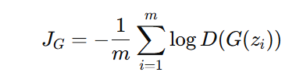

**Where:**

* **JGJ_G:** Measures how well the generator fools the discriminator.
* **D(G(zi)):** Probability of the discriminator classifying generated data as real.
* **Goal:** Minimize JG to maximize the likelihood of generated data being classified as real.

**2. Discriminator Model**

* **Purpose:** Distinguish between real and generated data.
* **Operation:** Acts as a binary classifier using neural networks (e.g., convolutional layers for image data).
* **Objective:** Accurately classify real and fake data.
* **Discriminator Loss:**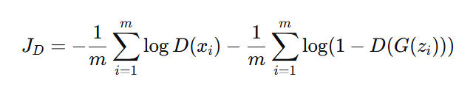

**Where:**

* **JD:** Measures the discriminator's ability to classify samples correctly.
* **D(xi):** Probability of classifying real data as real.
* **D(G(zi)):** Probability of classifying fake data as fake.
* **Goal:** Minimize JDJ_D to improve classification accuracy.

**3. Minimax Loss**

**The overall objective of a GAN is represented by the minimax loss:**

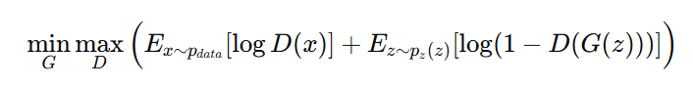

**Where:**

* **pdata(x):** Real data distribution.
* **pz(z):** Noise distribution.
* **D(x):** Probability of real data being classified as real.
* **D(G(z)):** Probability of fake data being classified as real.

**How Does a GAN Work?**

A **Generative Adversarial Network (GAN)** operates through an adversarial relationship between two neural networks: the **Generator (G)** and the **Discriminator (D)**. The process can be broken down into key steps:

**1. Initialization:**

* Two neural networks are initialized:
  + **Generator (G):** Creates synthetic data (e.g., images, text) from random noise.
  + **Discriminator (D):** Evaluates whether a given data sample is real (from the dataset) or fake (from G).
* Both networks are set up to optimize opposing objectives.

**2. Generator’s First Move:**

* The **Generator (G)** takes a **random noise vector (z)** as input.
* Using its neural layers, G transforms this noise into a **synthetic data sample** (e.g., an image).
* This sample is then passed to the Discriminator (D).

**3. Discriminator’s Turn:**

* The **Discriminator (D)** evaluates two types of data:
  + **Real data samples:** Directly from the training dataset.
  + **Fake data samples:** Generated by the Generator.
* D outputs a **probability score** for each sample:
  + **1:** Likely real.
  + **0:** Likely fake.

**4. The Learning Process (Adversarial Training):**

* The adversarial process starts here:
  + **If D correctly identifies real and fake samples:** Both networks are updated slightly.
  + **If G successfully fools D:** G gets a positive update, and D gets penalized.
* This process ensures both networks continuously improve.

**5. Generator’s Improvement:**

* **Goal:** Fool the Discriminator.
* When D **mistakenly labels fake data as real**, G receives significant positive feedback.
* This motivates G to **generate increasingly realistic data** over time.

**6. Discriminator’s Adaptation:**

* **Goal:** Correctly identify real and fake samples.
* When D **accurately identifies fake data as fake**, it receives positive feedback, reinforcing its ability to detect fake samples.
* Over time, D becomes **better at distinguishing fake from real data**.

**7. Continuous Refinement:**

* The adversarial duel between G and D continues iteratively.
* **G** improves at generating highly realistic samples.
* **D** improves at distinguishing real from fake.

**Advantages:**

1. **High-Quality Data Generation:**Produces realistic images, videos, and text.
2. **Versatility:** Can be used in various fields like art, healthcare, and finance.
3. **Data Augmentation:** Enhances datasets by generating additional data.
4. **Fraud Detection:** Helps in identifying fraudulent activities.
5. **Autonomous Training:** Learns and improves without much human intervention.

**Disadvantages:**

1. **Complexity:** Difficult to set up and train properly.
2. **Mode Collapse:** Sometimes generates limited or repetitive outputs.
3. **Resource-Intensive:** Requires significant computational power and data.
4. **Unstable Training:** Training can be unstable and hard to balance.
5. **Ethical Concerns:** Potential misuse for creating fake content.

**Applications of GANs:**

* **Image Synthesis:** Generating realistic images from noise.
* **Style Transfer:** Converting images into different artistic styles.
* **Text-to-Image Synthesis:** Generating images based on textual descriptions.